MATHEMATICS

YEAR 8 EXAM

SEMESTER ONE 2016

Part B – Calculators allowed 45mins

Name:_________________________________________

Teacher: _______________________________________

Class: ________________ /55

Part B
Calculators allowe

- Jane bought a packet of 12 Christmas cards for $15. Circle the correct mean price of the cards from the choices below? (1 mark)
  - $0.80
  - $1.25
  - $1.80
  - $3.00
- Justin collects football cards. He sells some of his cards for the following amounts. (1 mark)
$3 , $5, $5, $8, $8, $10, $10, $10, $40
- What is the mean price he got for the cards.

- Which value is an outlier

- Describe effect this outlier has on the median and the mean?

3. Convert the following to decimals and use recurring decimal if necessary. (3 marks)

$a. \frac{3}{4}$ = b. $\frac{2}{19}$ = d. $\frac{31}{27}$ =

- Are the statements below an example of a census or a sample? Explain your reasons. (10 Marks)
- Interviewing everyone at the canteen to determine how many students played sport.

- Adults voting at the Australian federal election.

- Phoning ever 10th parent for their opinion of the new school jacket.

- Asking all members of a class to put their hand up if they walked to school

- Having all car buyers at a dealership to complete a Customer Satisfaction survey once they complete a purchase.

- In each example below, a survey was conducted. State if these surveys would give an accurate result or could they be biased? Provide a reason for your answer. (8 Marks)

- A survey at a gym found that 90% of people exercise regularly.

- A survey at a retirement village, found that the TV show “Antiques roadshow” was more than twice as popular as “Game of Thrones”.

- A random survey at a local shopping centre found that 30% of people had travelled overseas in the last 2 years.

- A phone poll found that 44% of people supported increasing water restrictions

- This is a graph of preferred leisure activities of a Year 8 class. (5 Marks)
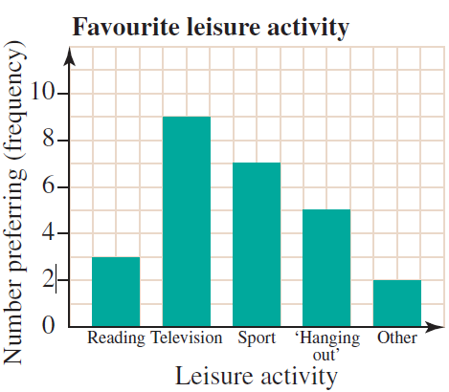

a) How many students preferred sport as a leisure activity?

b) How many students were in the class?

c) Which was the most favoured activity?

d) How many times more popular than reading was watching television?

e) Could this data be described as numerical or categorical?

- You’ve been asked to conduct a survey on students favourite drinks at the canteen.
a) Who would you survey and why to give an unbiased result. (2 Marks)

b) Two students have already completed surveys of year 8 students on their favourite drinks gave the following results.
Survey 1
Drink | Frequency
Juice | 7
Milk | 2
Iced Tea | 16
Soft drink | 21
Choc Milk | 12

Survey 2
Drink | Frequency
Juice | 2
Milk | 3
Iced Tea | 4
Soft drink | 6
Choc Milk | 1
Which survey of these surveys would you use to order more drinks for the canteen? State your reason why. (2 Marks)

8 The weight of luggage (kg) was recorded at an airline check-in counter and listed below.
25 | 30 | 8 | 58 | 41 | 58 | 12 | 13 | 22
34 | 37 | 78 | 10 | 42 | 7 | 19 | 18 | 15
47 | 29 | 22 | 40 | 25 | 20 | 20 | 32 | 27
a) How many people were surveyed? (1 Mark)

- Construct a stem-and-leaf plot of the data. (4 Marks)
Raw Data Ordered Data
Tens | Units
0
1
2
3
4
5
6
7
Tens | Units
0
1
2
3
4
5
6
7

Key | =
- From the stem and leaf diagram, find the median. (1 Mark)

- From the stem and leaf diagram find the mode. (1 Mark)

- Calculate the mean for the data. (1 Mark)

f) Which piece of data could be considered an outlier? (1 Mark)

g) If the outlier is removed from the data, what is the new mean? (1 Mark)

h) If the outlier is removed from the data, what is the new median? (1 Mark)

- Do you believe it is reasonable to remove the outlier from the data above? State a reason to explain your answer? (2 Mark)

- State if these are rational or irrational. (10 Marks)
$$\sqrt{2}$$
$$\sqrt{9}$$
$$\sqrt{125}$$
0.0898989…
$$\sqrt{10}$$
π
$$\sqrt[3]{8}$$
$$\frac{1}{2}$$
$$\frac{1}{9}$$
$$0.\dot{6}$$

THE END

